**The Racing Store**



by **Lachezar Mitov**

**Contents**

**Introduction** 3

**Git Repository** 3

**Website Credentials** 4

**Website Address** 4

**Target Audience** 4

**Website Description** 5

**Website Design** 5

Sitemap 6

**Database Design** 7

**Wireframes** 8

Home Page 8

Products Page 9

Order Page 10

Login Page 11

Account Page 12

About Us Page 13

Order Confirmed Page 14

# **Introduction**

The Racing Store is an e-commerce website intended to sell products connected to Formula 1.The online shop will provide its customers with the latest items from the teams that compete in the Formula 1 Championship.

# **Git Repository**

Here is the link to all the documentation and source code of this project:

<https://git.fhict.nl/I477927/lachezar-mitov-individual-project-1>

# **Website Credentials**

Down below are the credentials listed for logging in the website as a Customer:

**Username: gigi || Password: gigi**

# **Website Address**

Here is the link to the website on the Luna server:

[https://i477927.luna.fhict.nl](https://i477927.luna.fhict.nl/)

# **Target Audience**

This shop will sell merchandise from the 2022 Formula 1 Championship teams. As expected the main targeted audience will be the fans of the sport who will want to purchase an item of their favorite team or driver.

# **Website Description**

The website will provide the customers with a range of products from which they can order. An account management system will store users so that they can log in a personal page and modify their personal info. In order to develop the e-commerce shop, several technologies must be studied and understood. These include using the 3-tier Architecture approach. Firstly, for the storing of products, orders and users a back-end database is implemented. Moreover, the design of the website is created using the Razor Pages programming model. Finally, all these technologies are used with the objective to develop a website where a consumer can easily buy a product they want.

# **Website Design**

The store consists of 6 pages (Home, Products, About Us, Account, Order and Order Confirmed). From every page people will be able to navigate to the others pages easily with a navigation bar. Firstly, the Home page has some advertisement for new products in the shop and has some featured products that can spark interest in the customer. The Products page contains all the available product that the store has. For the time being the products available for the customers to purchase will be clothes and posters. But integration of other types products can be easily done because the structure is made open for extension. If the user wants to buy a product they can easily do it by pressing a ‘Buy’ button underneath the product which will redirect them to a page where the order can be finalized. When a user makes an order an account is being created too if they don’t already have one and if the order was successful the user will be redirected to Order Confirmed page. After a user logs in the Account page a personal information about them will be shown which they can change whenever they want.

The navigation design of the pages can be seen below(Sitemap).

The Desktop application will play part in adding the products and their respective description, stock and price. In addition, the application will manage all existing users and orders in the database. Moreover, the database will keep track of all the items in the shop and the users that are registered on the website and their information such as username, password, phone number, address, email, etc. Finally, the database will keep track of the orders and their status (Shipped, to be Shipped).

## Sitemap

# **Database Design**

The website has a database so that all information like new and current users, all the order information and the products list is kept somewhere at all times in order for the website to operate correctly. The design of the database consists of 5 tables (Users, Orders, Products, Clothes and Posters). Users table contains all the information of the users as well as a unique identifier for each person, which is used in other tables. Orders table has data for the product and the user and its address information for each order that has been made. Product has the information of all the products in the database. Each product has a unique identifier and a type. If the product type is “Clothing” information about the size of this product is kept in the Clothes table with its id. And if the type is “Poster” information about the dimensions of this product is kept in the Posters table with its id.

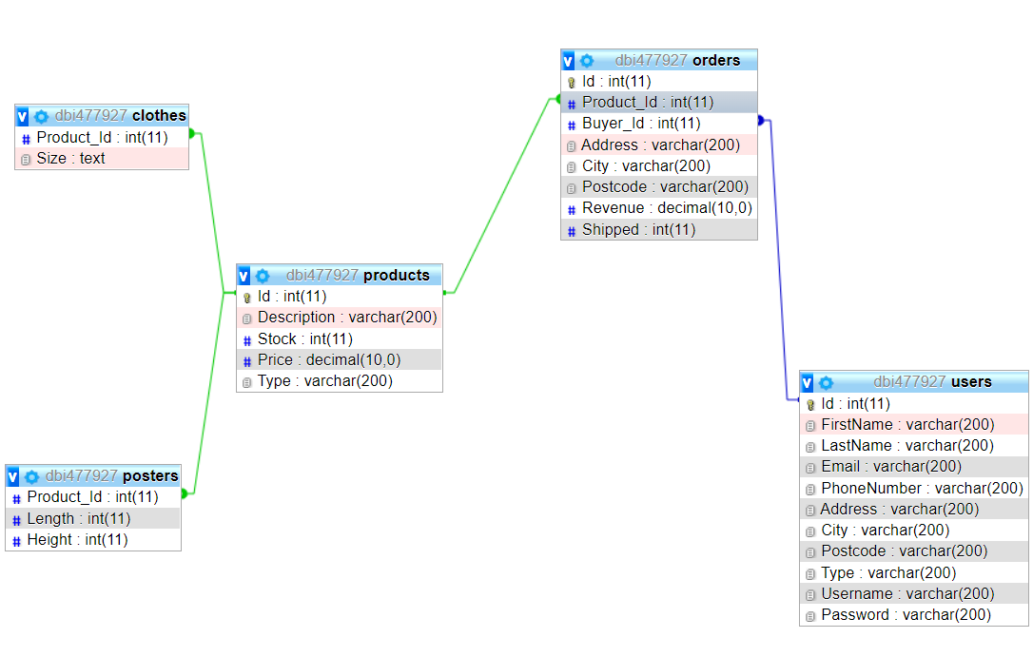

# **Wireframes**

The wireframes will show how the different pages of the website will look.

## Home Page

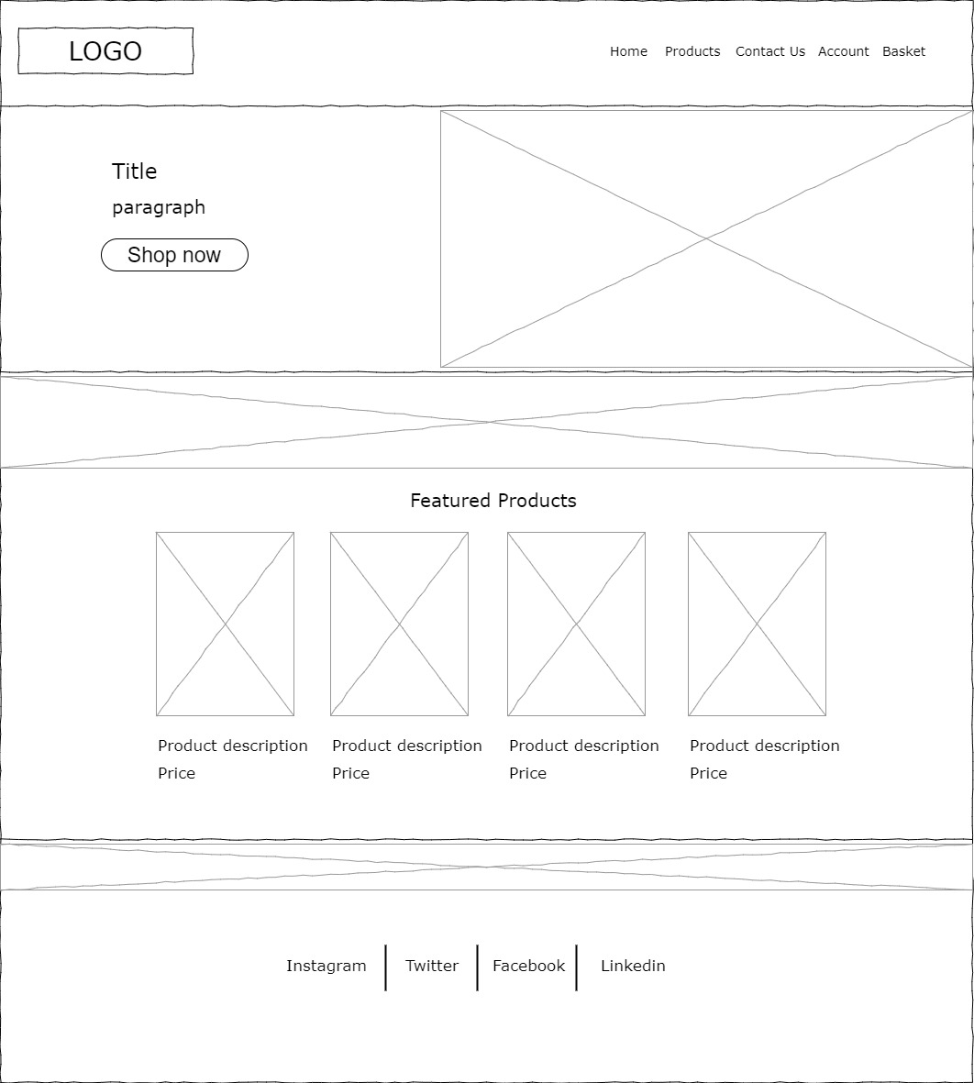

## Products Page

## Order Page

## Login Page

## Account Page

## About Us Page

## Order Confirmed Page

